Blood Donation Camp

Introduction
A webpage and database is created to store data of donors wishing to register for blood donation.

Step 1: Index.php
  - This file defines the web page for the insertion of data by user. It is designed to take the following inputs from user:
- Name
- Email
- Phone Number
- Blood Group
- Age
- Gender

Step 2: Insert.php
  - The file uses php to establish a connection with the database created (blood_donation_camp) using host, username,password and database name.
  - The connection is checked to be successful or not.
  - The form data from index.php is acquired and inserted into database.
  - Once the data is successfully uploaded in the database it displays the message “ Registration successful”.
- The created files with .php are stored in the htdocs of Xampp folder inorder to execute.
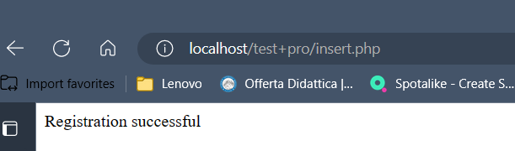

Step 3: Creation of database to store data
# mysql -uroot –p
- 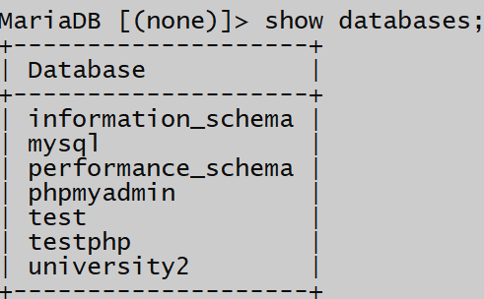
Shows the existing databases.–
Creation of database
- 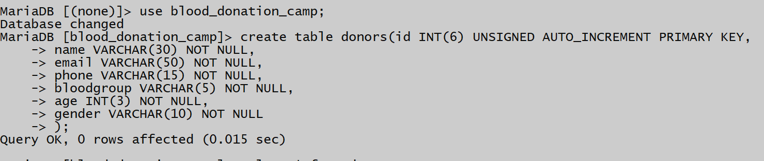
Using the database and creating a table named donors to store the data form index.php.
- 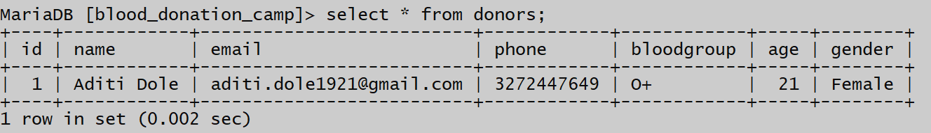
Displays the data stored in database

Index.php
  - Output

localhost/index.php

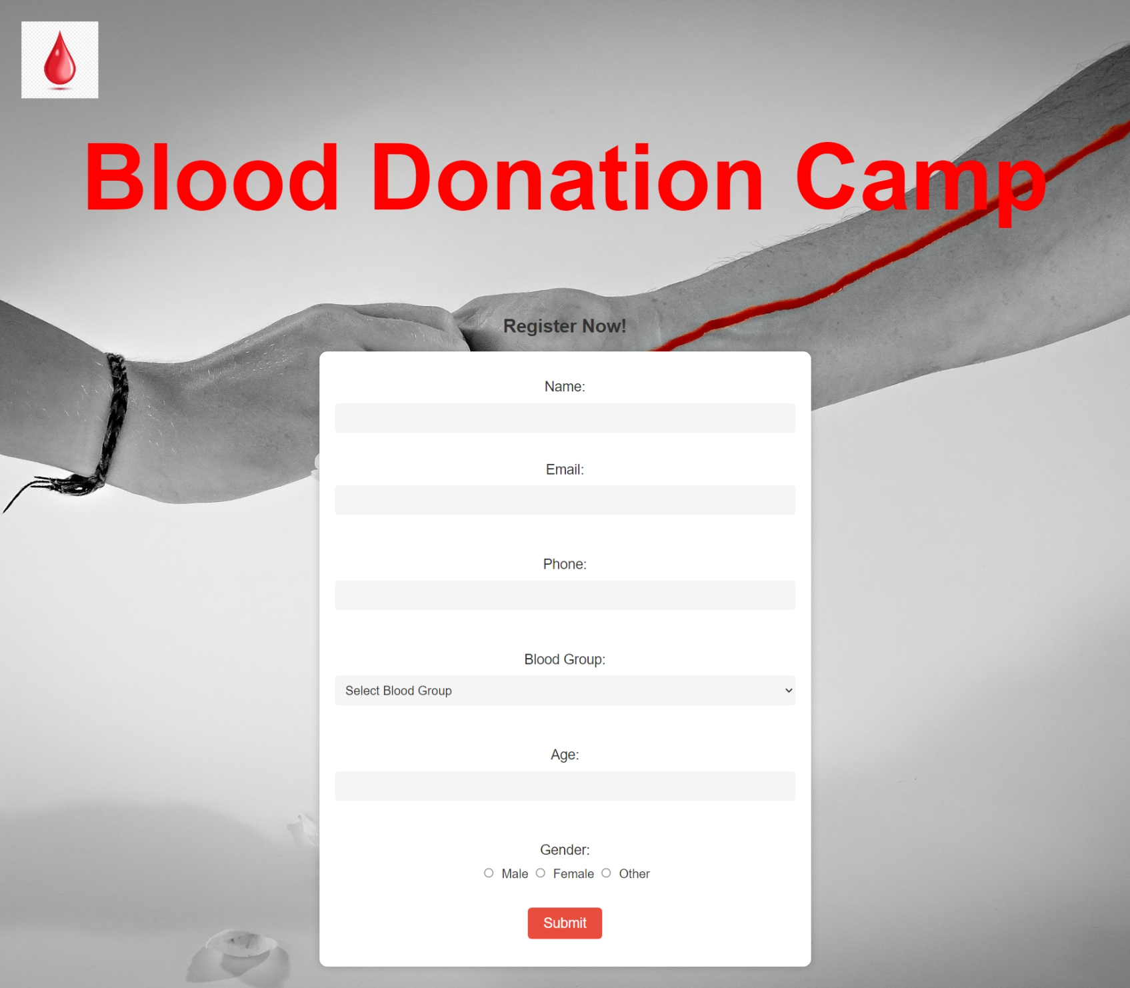

Directs to insert.php

